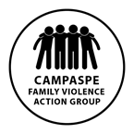Campaspe Family Violence Action Group

- Primary Prevention working group

TERMS OF REFERENCE

Purpose of the Primary Prevention working group
To develop an action plan to implement the agreed key objectives and actions from the CFVAG strategic planning session key strategic priority 3 - A Campaspe that understands the gendered dynamics of family violence, the first causes of family violence, and that family violence can be prevented from happening in the first place.

This group’s agreed understanding of primary prevention is reflected by the following diagram. The activities undertaken by the group will be based on primary initiatives that are whole-of-population and universal in their approach rather than targeted secondary or tertiary actions.

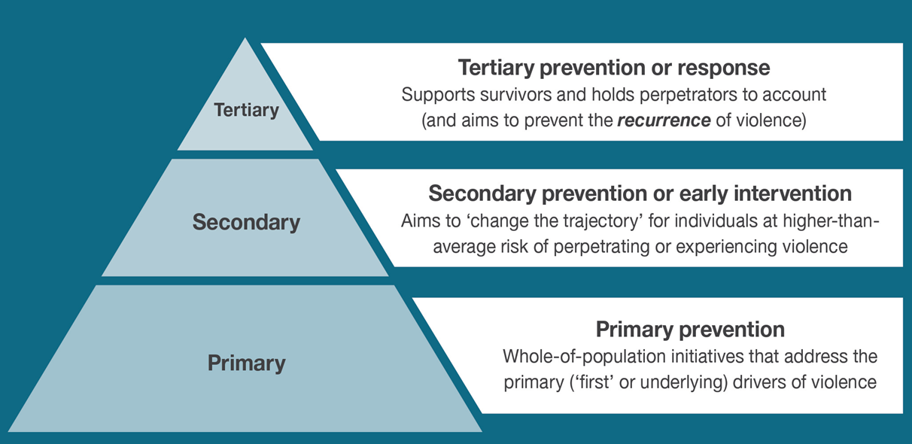

Key objectives and actions
Key Priority 3.
A Campaspe that understands the gendered dynamics of family violence, the first causes of family violence, and that family violence can be prevented from happening in the first place

‘Preventing family violence is everyone’s business’; ‘Gender inequality is the problem, gender equality is the solution’

- Develop and implement a communications strategy to underpin and support all other actions undertaken by the partnership (i.e. to lend coherence to)

- Develop/utilise specific primary prevention messages that clearly reference ideas such as ‘Preventing family violence is everyone’s business’ or ‘Gender inequality is the problem, gender equality is the solution’

- Develop a suite of information or resources that include primary prevention messages, to support all other actions of CFVAG

Additional objective;
To support primary prevention funding opportunities should they arise. Any funding opportunities will be recommended to CFVAG for approval and sign-off.

Participants
Campaspe PCP (convenor and chair)
Centre for Non-Violence
Women’s Health Loddon Mallee
Kyabram Community Learning Centre
Echuca Regional Health
Kyabram District Health
Njernda Aboriginal Corporation
Loddon Campaspe Indigenous Family Violence Regional Action Group (LC-IFRAG)
Department of Education
Rochester & Elmore District Health Service
Campaspe Shire Council

Invite other stakeholders on as needed basis dependent on specific topic areas.

Meetings
Meetings are to be held on a monthly basis for the first 6 months; frequency to be reviewed post initial six months.
Meetings will be held on second Tuesday of each month from 10am-11:30am as agreed by participants
Meeting locations will be rotated across Echuca, Rochester and Kyabram as per meeting schedule with teleconferencing and videoconferencing to be available where possible;

CFVAG Prevention working group  - Chair Emma Brentnall Campaspe PCP | Tuesday 13 March 10am | Echuca Regional Health
 | Tuesday 10 April 10am | Rochester
 | Tuesday 8 May 10am | Kyabram
 | Tuesday 12 June 10am | Echuca
 | Tuesday 10 July 10am | Rochester
 | Tuesday 14 August 10am | Kyabram

Quorum for Meetings
A minimium of four members are to be present to form a quorum in support of meeting discussions. If a quorum is not available, key discussions shall occur via email to ensure progress on initiatives continues.

Reporting Mechanisms
Meeting minutes will be shared with all members.
Recommendations and reports shall be provided to the Campaspe Family Violence Action Group.
Members are responsible to share information and activities of the working group with their respective organisations to ensure

Chairperson & Secretary Roles
The chairperson role will be the Campaspe Primary Care Partnership as sponsor for this priority area.
The minute taker will also be Campaspe Primary Care Partnership and or rotated as needed.
Agenda items are to be confirmed at the end of each meeting. Additional agenda items shall be forwarded to Chair and secretary
The sponsor organisation will be responsible for circulation of the minutes and agendas (one week prior to the meeting where possible).

Supporting documents
- CFVAG Strategic Directions

- Key messages infographic

- Change the story framework for the prevention of violence against women and children
https://www.ourwatch.org.au/getmedia/0aa0109b-6b03-43f2-85fe-a9f5ec92ae4e/Change-the-story-framework-prevent-violence-women-children-AA-new.pdf.aspx

- “Let’s change the story: Violence against women”
https://www.youtube.com/watch?v=fLUVWZvVZXw

- The Loddon Mallee Action Plan for the primary prevent ion of violence against women
http://www.whlm.org.au/wp-content/uploads/2016/02/WHLM-Action-Plan-PPVAW-2016-2019.pdf

Author | Version | Implemented | Review
Campaspe PCP Executive Officer | v.2 | March 2018 | Annual

