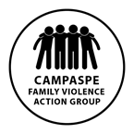Campaspe Family Violence Action Group

- Gender Equity working group

TERMS OF REFERENCE

Purpose of the Gender Equity Working Group
To develop an action plan to implement the agreed key objectives and actions from the CFVAG strategic planning session key strategic priorities 1 &2:

- Organisations are gender equitable in their practices and promote equal and respectful relationships between men and women.
- A Campaspe that promotes and values women’s equal participation and leadership in public and private life.

This group’s agreed understanding of primary prevention is reflected by the following diagram. The activities undertaken by the group will be based on primary initiatives that are whole-of-population and universal in their approach rather than targeted secondary or tertiary actions.

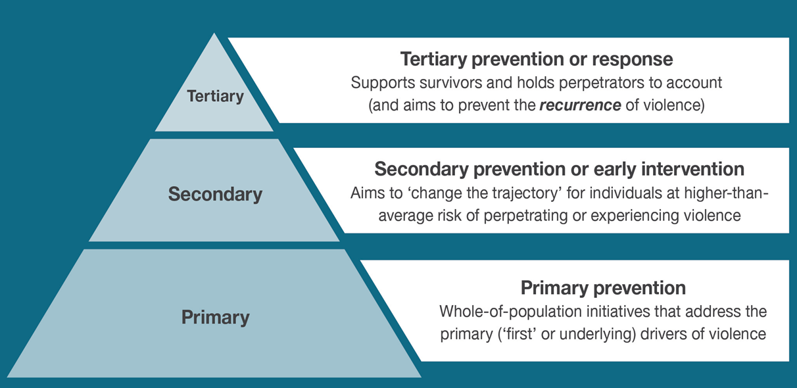

Key objectives and actions
Key Priorities 1 &2.
Priority 1 Organisations are gender equitable in their practices and promote equal and respectful relationships between men and women.

- Use existing resources to develop a package to progress gender equity in Campaspe workplaces. The package is to include audit tools, skills development, women’s Leadership and mentoring programs. The package is to be drawn from existing best-practice gender equity
- As part of the gender equity package, provide skills development/capacity building activities to participating workplaces (e.g. gender equity training, bystander training).

Priority 2 A Campaspe that promotes and values women’s equal participation and leadership in public and private life.

- Undertake advocacy activities to increase support for the participation/leadership of women in non-traditional (paid) roles or sectors of employment.
- Challenge rigid gender norms and stereotypes and encourage inclusive respectful relationships.
Members
Women’s Health Loddon Mallee
Centre for Non-violence
Kyabram Community Learning Centre
Echuca Regional Health
Campaspe Shire Council
Victoria Police

Invite other stakeholders on as needed basis dependent on specific topic areas.

Meetings
Meetings are to be held on a monthly basis for the first 6 months; frequency to be reviewed post initial six months.

Meetings will be held on every 4th Wednesday of the month from 12-1 or otherwise as agreed by participants.

CFVAG Gender equity working group  - Chair/s: Marnie Jewell and Geoff Owen |  | Echuca
 |  | Rochester
 |  | Kyabram
 |  | Echuca
 |  | Rochester
 |  | Kyabram

Quorum for Meetings
A minimium of 3 members are to be present to form a quorum in support of meeting discussions. If a quorum is not available, key discussions shall occur via email to ensure progress on initiatives continues.

Reporting Mechanisms
Meeting minutes will be shared with all members.
Recommendations and reports shall be provided to the Campaspe Family Violence Action Group.
Members are responsible to share information and activities of the working group with their respective organisations.

Chairperson & Secretary Roles
The chairperson role will be shared between VicPol and WHLM. The minute taker will be rotated.

Agenda items are to be confirmed at the end of each meeting. Additional agenda items shall be forwarded to Chair and secretary

WHLM will be responsible for circulating the minutes and agendas (one week prior to the meeting where possible).

Supporting documents
- CFVAG Strategic Directions

- Key messages infographic

- Change the story framework for the prevention of violence against women and children
https://www.ourwatch.org.au/getmedia/0aa0109b-6b03-43f2-85fe-a9f5ec92ae4e/Change-the-story-framework-prevent-violence-women-children-AA-new.pdf.aspx

- “Let’s change the story: Violence against women”
https://www.youtube.com/watch?v=fLUVWZvVZXw

- The Loddon Mallee Action Plan for the primary prevent ion of violence against women
http://www.whlm.org.au/wp-content/uploads/2016/02/WHLM-Action-Plan-PPVAW-2016-2019.pdf

